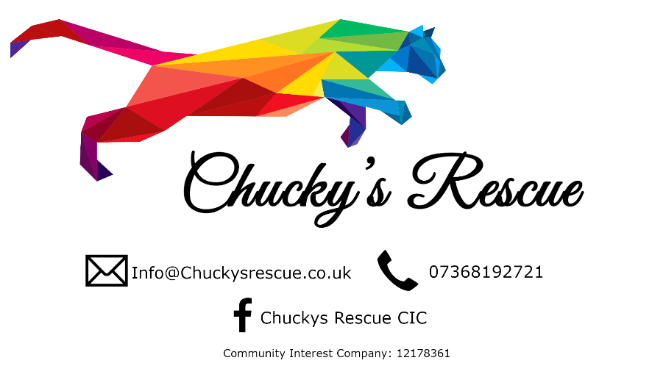

VOLUNTEER FORM - CIC Number 12178361

Welcome To Chuckys. We Are A Non Profit Community Interest Company set up to assist with Cat Rescue/Rehoming & Reuniting Lost & Found Cats with Their Owners. 

NAME: ….....................................................................................................................................

ADDRESS: ….................................................................................................................................

………………………………………………………………………………………………………………………………………………

POSTCODE..................................................................................................................................

TELEPHONE NO: …......................................................................................................................

EMAIL ADDRESS: …......................................................................................................................

Experience of Volunteering, Cats & Rescue Work

…....................................…......................................….................................................................

….....................................….......................................…...............................................................

…....................................…......................................….................................................................

….....................................….......................................…...............................................................

How would you like to volunteer with Chucky’s Cat Rescue? (Select all that apply).

Home Visits

Transporting Pets

Fundraising Events

Help with Advertising

Availability to help: (days / times..etc can or cannot do)

…....................................…......................................….................................................................

….....................................….......................................…...............................................................

…....................................…......................................….................................................................

….....................................….......................................…...............................................................

Is there any other information you would like to share with us?

…....................................…......................................….................................................................

….....................................….......................................…...............................................................

…....................................…......................................….................................................................

….....................................….......................................…...............................................................

I agree that I have read and understand the Code of Conduct of Chucky’s Cat Rescue and agree to comply with it. I confirm that the list above is accurate.  
  
  
  
Signature ………………………………………………………………….

Print Name ………………………………………………………………….   
  
  
Date …………………………